Suricat Website Redesign (Landing Page)

CTAs:
Only three CTAs 1) Join as a Design Partner 2) Request a Free Pilot 3) Got Questions?

1) Hero Section Message:

The Sentinel for Compliance Intelligence
Suricat works alongside QMS to uncover potential compliance gaps in documentation, trace each finding to its source, and help QA/RA teams address issues before an auditor finds them.


Dynamic Visual for the HERO Section

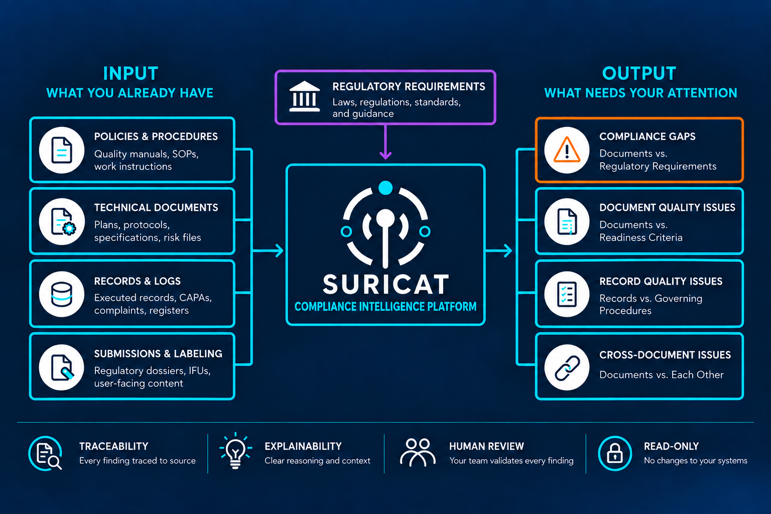

Hero Visual: Animation Instructions

Use the above Hero visual as the base. The animation brings it to life. You may polish the design, but keep the structure, content, relationships, and colors exactly as shown.

1.1 Before You Start

Build it as layered vector (SVG), with each of these on its own layer so it can be animated independently:

every input card

the Regulatory Requirements card

the Suricat Engine box

every output card

every connecting line and arrow

each of the four trust principles

Replace the mark in the Engine box with the official Suricat logo file. Do not redraw it.

Keep all text as real web text, not part of an image.

Do not show internal architecture anywhere in this visual. That includes CIS, Regulatory Ontology, Knowledge Graph, Compliance Reasoning, QVR, and individual engines.

Definition: "Briefly emphasize" means raising the element's brightness or border slightly for about 0.3 seconds, then returning it to normal. No scaling, movement, or glow.

1.2 Default and Starting State

The complete static visual is the default. The page must show the full Hero visual, fully visible, without depending on JavaScript or the animation loading successfully.

Apply the starting state before the Hero's first paint. Visitors must never see the complete visual switch to the starting state after it has appeared. If the animation cannot be prepared in time, keep the complete static visual and skip the animation.

Once the animation is ready, the starting state is:

Full brightness: all input cards, Regulatory Requirements, the Suricat Engine, all output cards, and the four trust principles.

Subdued, at about 30 percent opacity: all connecting lines and arrows.

Compliance Gaps: keeps its orange border and icon throughout. It is briefly emphasized during Step 4 without changing color.

No movement of any kind.

If the animation cannot run, visitors see the complete static visual and never a partially faded one.

1.3 Line Rule

Animate only the connecting lines. Draw each line once, in the direction its arrow points, from start to end.

Keep all cards, icons, and text stationary.

Leave each line fully visible after it is drawn. The faint line serves as a guide, and the drawn line replaces it.

1.4 Trigger

Start about 0.5 to 0.75 seconds after the Hero loads.

Play once per page visit.

The full sequence takes about 5 seconds.

The animation must never delay the headline, the sub-headline, or page loading.

1.5 Step-by-Step Sequence

The timings are guidelines and can be adjusted during implementation. The story to protect: your information and the requirements go into Suricat, and what needs your attention comes out.
Stage | Timing
What You Already Have | 0.0 to 1.0 seconds
Regulatory Requirements | 1.0 to 1.75 seconds
The Suricat Engine | 1.75 to 2.5 seconds
What Needs Your Attention | 2.5 to 4.0 seconds
Trust and Control | 4.0 to 5.0 seconds

Step 1: What You Already Have (0.0 to 1.0 seconds)

Briefly emphasize the four input cards together.

Simultaneously draw their teal connecting lines toward the Suricat Engine, with the arrowhead arriving last.

Step 2: Regulatory Requirements (1.0 to 1.75 seconds)

Briefly emphasize the Regulatory Requirements card, keeping its violet treatment.

Draw the violet line downward into the Suricat Engine, with the arrowhead arriving last.

Step 3: The Suricat Engine (1.75 to 2.5 seconds)

Briefly emphasize the Engine box outline once.

Hold briefly. Do not use ripple, rotation, pulsing, or continuous animation.

Step 4: What Needs Your Attention (2.5 to 4.0 seconds)

Draw the teal lines from the Engine toward the outputs, with the arrowheads arriving last.

After the output connections are drawn, briefly emphasize the four output cards in sequence: Compliance Gaps, Document Quality Issues, Record Quality Issues, and Cross-Document Issues. Adjust the timing slightly if needed, so each category is clearly visible without rushing the animation.

Compliance Gaps keeps its orange treatment and does not change color.

Do not animate any output as an alert, such as flashing or shaking.

Step 5: Trust and Control (4.0 to 5.0 seconds)

Briefly emphasize the four trust principles from left to right: Traceability, Explainability, Human Review, and Read-Only.

1.6 Final Resting State

All movement stops.

The visual matches the static Hero exactly, with every element at full brightness.

Do not loop or replay automatically.

This frame also serves as the static version for presentations and PDFs.

1.7 Hover Interaction (After the Animation)

Highlight style. Hover highlights the relevant elements without dimming the rest of the visual:

Selected cards get a slightly brighter border.

Their connecting lines become slightly thicker and fully opaque.

All other elements keep their normal appearance.

Shared connecting lines. When several cards share a connecting line, highlight the selected card's individual branch and the shared path to the Engine. Do not highlight unrelated cards.

Hovering over an input card highlights that card and its path into the Suricat Engine. Do not connect an individual input to a specific output.

Hovering over Regulatory Requirements highlights Regulatory Requirements, the violet line, the Engine, and Compliance Gaps.

Hovering over an output card highlights the information typically used to evaluate that type of finding, plus the paths through the Engine:
Hover over | Highlight
Compliance Gaps | Policies & Procedures, Technical Documents, Submissions & Labeling, Regulatory Requirements
Document Quality Issues | Policies & Procedures, Technical Documents, Submissions & Labeling
Record Quality Issues | Records & Logs, Policies & Procedures
Cross-Document Issues | Policies & Procedures, Technical Documents, Submissions & Labeling

These highlights illustrate typical information relationships. They are not exhaustive or mandatory source mappings. Actual finding-level traceability is demonstrated within the product.

Also:

Use highlighting only. Never animate data moving backward toward the inputs.

Make the output cards subtly discoverable with a pointer cursor and a slight border brightening. Do not add "hover to explore" text.

When the pointer leaves, return to the resting state.

Keyboard focus produces the same effect as hover.

The four trust principles are not interactive.

1.8 Reduced Motion

For visitors with reduced motion enabled:

Skip the animation and show the complete static visual immediately.

Keep the hover and keyboard interaction, using highlighting only and no drawing motion.

1.9 Visual and Motion Rules
Color | Use
Deep Navy #0D1B3E | Background
Intelligence Teal #19D3C5 | Inputs, Suricat connections, and normal outputs
Deep Violet #5C3D8F | Regulatory Requirements and its connection only
Orange #FF6B35 | Compliance Gaps only
Pure White #FFFFFF | Primary text

Use:

Smooth ease-in-out timing

Drawing effects on lines only

Do not use:

Looping or continuous movement

Particles, pulsing, rotating, ripples, or glow effects

Two-way arrows

Any movement flowing from Suricat back toward the inputs

Anything suggesting Suricat modifies customer systems or monitors them in real time

Performance: Use lightweight, web-native SVG and CSS animation, or a small Lottie file. Never use video.

1.10 Test for Success

After watching once, a QA/RA visitor should understand:

This is the information I already have, and these are the requirements that govern it.

Suricat brings the two together and shows me what needs my attention.

Findings can be traced to their source. My team validates them, and Suricat does not change my systems.

2) THE COST OF MISALIGNMENT
Gaps between your documentation and the requirements that govern it can stay hidden until an audit, inspection, or recall exposes them. By then, the cost can reach far beyond compliance.
Suricat helps you find those gaps first.
[Six sourced evidence/data cards]

3) THE ALIGNMENT GAP

(I suggest we keep this section ½ and ½ as we did in our previous website).

Left Half:

Your Systems Are in Place. Alignment Is the Hard Part.
Requirements change. Documents evolve. Evidence accumulates.
Procedures, risks, controls, CAPAs, design documentation, and training records are all connected, even across different systems.
When one changes, what else is affected?
Suricat shows you the impact across those connections.
Right Half: (A Dynamic image)

The Alignment Gap Dynamic Visual:
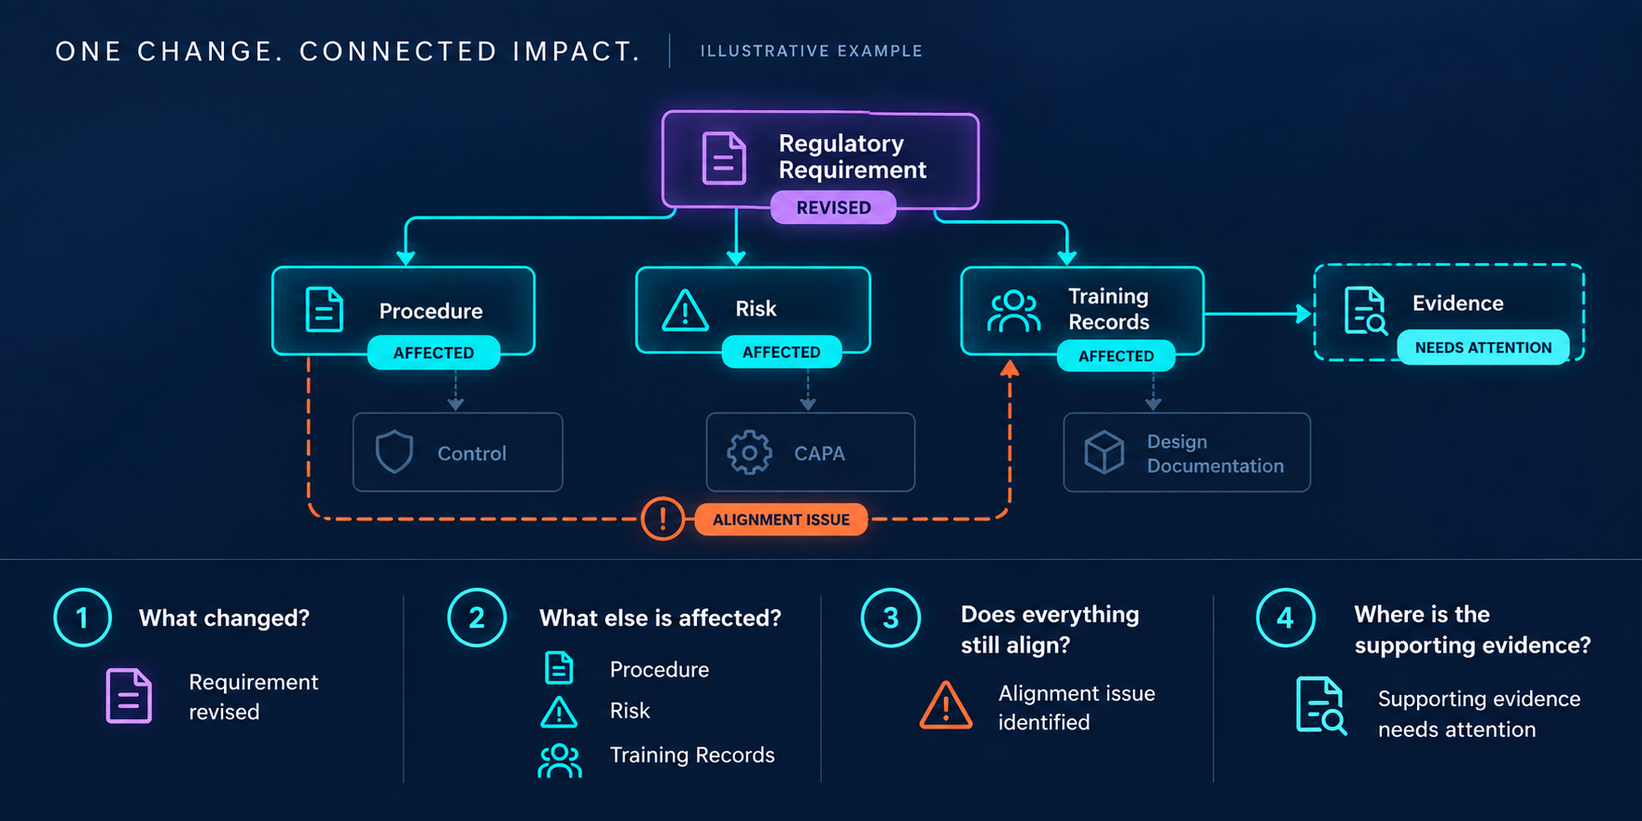

The Alignment Gap Visual: Animation Instructions

Use the attached Alignment Gap visual as the base. The animation brings it to life. You may polish the design, but keep the structure, content, relationships, and colors exactly as shown.

1. Purpose

The visual answers the question from the left side of the section: "When one changes, what else is affected?"

It demonstrates the promise: Suricat shows you the impact across those connections.

This section shows change impact. The Hero shows findings and traceability. Do not introduce the Suricat Engine, "trace to source," "Ready for Review," or other Hero concepts here.

2. Visual Structure

Keep the existing structure exactly as shown:

Title: ONE CHANGE. CONNECTED IMPACT.

Secondary label: ILLUSTRATIVE EXAMPLE. Keep this label. The relationships and the issue shown are illustrative, not a claim that every regulatory change produces these exact consequences.

Top: the Regulatory Requirement node, in violet, with the REVISED tag.

Affected row: Procedure, Risk, and Training Records, each with an AFFECTED tag.

Evidence: a dashed teal node to the right of Training Records, with the NEEDS ATTENTION tag.

Quiet row: Control, CAPA, and Design Documentation, each gray and connected by a subdued dashed line.

Orange alignment path: a dashed line running from Procedure, below the quiet row, up into Training Records, with the "!" marker and the ALIGNMENT ISSUE tag.

Question panel: four numbered questions, each with an icon and an answer.

3. Before You Start

Build it as a layered vector (SVG). Put each of these on its own layer so it can be animated independently:

every node

every connecting line and arrow

every status tag (REVISED, AFFECTED, ALIGNMENT ISSUE, NEEDS ATTENTION)

the orange alignment path and its "!" marker

each question's number circle, icon, question text, and answer

Also:

Keep all text as real web text, not part of an image.

Use the node name "Regulatory Requirement" everywhere, exactly as shown in the image.

Definitions:

"Briefly emphasize" means raising the element's brightness or border slightly for about 0.3 seconds, then returning it to normal. No scaling, movement, or glow.

"Appear" means fading in over about 0.3 seconds. No scaling or movement.

4. Default and Starting State

The complete static visual is the default. The page must show the full final visual, with all tags, the alignment path, and all four answers, without depending on JavaScript or the animation loading.

Prepare the starting state before the visual enters the visitor's viewport. Do not visibly reset the completed illustration after it has appeared. If the animation cannot be prepared in time, keep the complete static visual and skip the animation.

Once the animation is ready, the starting state is:

Nodes: all eight are visible. Regulatory Requirement, Procedure, Risk, Training Records, and Evidence start neutral, with no active borders. Control, CAPA, and Design Documentation appear exactly as they do in the final image.

Regulatory Requirement: a soft violet outline only.

Connecting lines: subdued, at about 30 percent opacity.

Status tags: none visible.

Orange alignment path and "!" marker: not visible.

Evidence: no dashed teal outline yet.

Question panel: all four questions, including their number circles, icons, and answers, are visible but dimmed.

Movement: none of any kind.

If the animation cannot run, visitors see the complete static visual and never an incomplete one.

5. Line Rule

Animate only the connecting lines. Draw each line once, in the direction its arrow points, from start to end, and leave it fully visible afterward. The faint line serves as a guide, and the drawn line replaces it.

Dashed orange alignment path: reveal it along its route, for example with a mask, while keeping the dash pattern fixed. The dashes must never appear to move.

Nodes, icons, and text stay stationary. Tags, borders, and answers only change or appear.

Quiet connections: the dashed lines to Control, CAPA, and Design Documentation stay subdued throughout and are never animated.

6. Trigger

Start when about 70 to 75 percent of the visual is visible on screen.

Play once per page visit.

The full sequence takes about 5.5 seconds.

7. Step-by-Step Sequence

The timings are guidelines and can be adjusted during implementation. The story to protect is: one change, then connected items affected, then a potential alignment issue, then evidence that needs attention.
Stage | Timing
What changed? | 0.0 to 1.0 seconds
What else is affected? | 1.2 to 2.6 seconds
Does everything still align? | 2.8 to 4.2 seconds
Where is the supporting evidence? | 4.4 to 5.5 seconds

Step 1: What changed? (0.0 to 1.0 seconds)

The Regulatory Requirement node changes from its soft outline to its full violet border.

The violet REVISED tag appears.

Question 1, including its violet icon, and its answer "Requirement revised" come to full brightness.

Hold briefly.

Step 2: What else is affected? (1.2 to 2.6 seconds)

Draw the three teal lines outward from Regulatory Requirement to Procedure, Risk, and Training Records at the same time, with the arrowheads arriving last.

As the lines arrive, Procedure, Risk, and Training Records change from neutral to their active teal borders.

The AFFECTED tag appears on each of the three nodes.

Question 2, including its three icons, and its answer "Procedure · Risk · Training Records" come to full brightness.

Control, CAPA, and Design Documentation stay quiet.

Step 3: Does everything still align? (2.8 to 4.2 seconds)

All other connections stay stationary. Only the orange alignment path is revealed in this step.

Reveal the orange dashed path from Procedure, along its route below the quiet row, up to Training Records, with the arrowhead arriving last.

The orange "!" marker and the ALIGNMENT ISSUE tag appear.

Question 3, including its orange icon, and its answer "Alignment issue identified" come to full brightness.

Present the orange relationship as a potential alignment issue in this illustrative example, not an inevitable consequence of every regulatory change:

Reveal it at the same calm pace as the other steps.

Do not flash, shake, or add alert-style emphasis.

Keep the ILLUSTRATIVE EXAMPLE label visible throughout.

Step 4: Where is the supporting evidence? (4.4 to 5.5 seconds)

Draw the teal line from Training Records to Evidence, with the arrowhead arriving last.

Evidence's dashed teal outline and the NEEDS ATTENTION tag appear. Evidence stays teal and never turns orange.

Question 4, including its teal icon, and its answer "Supporting evidence needs attention" come to full brightness.

8. Final Resting State

All movement stops.

The visual matches the attached image exactly, with every tag, border, line, the alignment path, and all four answers at full brightness.

Control, CAPA, and Design Documentation remain visibly quieter than the affected nodes.

Do not loop or replay automatically.

This frame also serves as the static version for presentations and PDFs.

9. Question Interaction (After the Animation)

Hovering over one of the four questions highlights the parts of the map for that step. Nothing else is dimmed.

Selected nodes get a slightly brighter border.

Their connecting lines become slightly thicker and fully opaque.

All other elements keep their normal appearance.
Hover over | Highlight
What changed? | Regulatory Requirement
What else is affected? | Regulatory Requirement, Procedure, Risk, Training Records, and their connecting lines
Does everything still align? | Procedure, the orange alignment path, and Training Records
Where is the supporting evidence? | Training Records, its line to Evidence, and Evidence

Also:

Give each question a subtle hover cue, such as a slight brightening. Do not add "hover to explore" text.

When the pointer leaves, return to the resting state.

Keyboard focus produces the same effect as hover.

The nodes themselves are not interactive.

10. Reduced Motion

For visitors with reduced motion enabled:

Skip the animation and show the complete static visual immediately.

Keep the question interaction, using highlighting only and no drawing motion.

11. Visual and Motion Rules
Color | Use
Deep Navy #0D1B3E | Background
Intelligence Teal #19D3C5 | Affected nodes, their connections, Evidence, and teal tags
Deep Violet #5C3D8F | Regulatory Requirement node, REVISED tag, and question 1 icon (a lighter tint is allowed for contrast)
Orange #FF6B35 | Alignment path, "!" marker, ALIGNMENT ISSUE tag, and question 3 icon only
Pure White #FFFFFF | Primary text

Status never depends on color alone. Always show the text tags: REVISED, AFFECTED, ALIGNMENT ISSUE, and NEEDS ATTENTION.

Glow: The soft static glow shown in the artwork may remain. Do not add or animate glow as an effect.

Use:

Smooth ease-in-out timing

Drawing effects on lines only

Do not use:

Looping or continuous movement

Particles or pulsing

Animated glow

Two-way arrows or crossing lines

Moving or crawling dashes

Alert-style effects such as flashing or shaking

Any movement flowing back toward Regulatory Requirement

Anything suggesting continuous or real-time monitoring

Performance: Use lightweight, web-native SVG and CSS animation, or a small Lottie file. Never use video.

12. Test for Success

After watching once, a QA/RA visitor should understand:

One change happened.

It affected connected information.

A potential alignment issue was identified, and supporting evidence needs attention.

That delivers the section's promise: Suricat shows you the impact across those connections.

4) WHERE EXISTING SYSTEMS STOP

Your Systems Manage the Information. Connecting It Is Still Your Job.
Your QMS and other systems manage documents, records, workflows, and approvals.
But compliance depends on understanding how that information relates to applicable regulations and standards, and to your other documents and records.
The information is there. The intelligence across it is not.
Suricat connects what your systems manage and shows you where it no longer aligns.

WHERE EXISTING SYSTEMS STOP Dynamic Visual

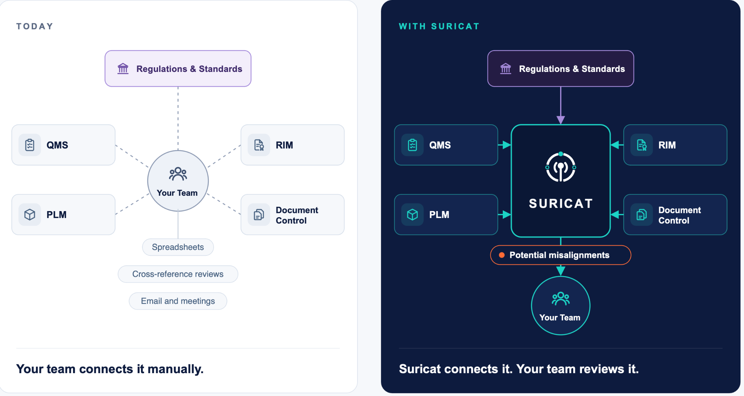

Where Existing Systems Stop Visual: Animation Instructions
Use the attached visual exactly as it is. The animation brings it to life. It must not change the layout, copy, colors, icons, or spacing.

1. Purpose
This section's headline is "Your Systems Manage the Information. Connecting It Is Still Your Job." The visual shows that job being done by hand today, then shows Suricat taking it over.
It demonstrates the section's closing line: Suricat connects what your systems manage and shows you where it no longer aligns.
This section shows who does the connecting. The Hero shows findings and traceability, and The Alignment Gap shows change impact. Do not introduce output categories, trace chains, or status tags from those visuals here.

2. Visual Structure
Keep the existing structure exactly as shown.
Left panel: TODAY (light background)
- Regulations & Standards card at the top, in violet
- QMS, RIM, PLM, and Document Control cards, in gray
- The Your Team circle in the center, connected to all five cards by dashed gray lines
- A short solid line from Your Team down to three method labels: Spreadsheets, Cross-reference reviews, and Email and meetings
- Caption: Your team connects it manually.
Right panel: WITH SURICAT (Deep Navy background)
- Regulations & Standards card at the top, with a violet arrow down into Suricat
- QMS, RIM, PLM, and Document Control cards, with teal arrows into the Suricat box
- The Suricat box in the center, with the Suricat logo and name
- A teal line from Suricat down through the Potential misalignments label (orange outline and dot) to the Your Team circle
- Caption: Suricat connects it. Your team reviews it.
The core message is the position of Your Team. On the left, the team is in the middle, doing the connecting. On the right, the team is at the end, reviewing the result.

3. Before You Start
Build it as layered vector (SVG). Put each of these on its own layer so it can be animated independently:
- every card
- every line, line segment, and arrow
- each Your Team circle
- the three method labels
- the Suricat box
- the Potential misalignments label
- both panel labels (TODAY, WITH SURICAT) and both captions
Also:
- Replace the mark in the Suricat box with the official Suricat logo file. Do not redraw it.
- Keep all text as real web text, not part of an image.
Definition: "Briefly emphasize" means raising the element's brightness or border slightly for about 0.3 seconds, then returning it to normal. No scaling, movement, or glow.

4. Default and Starting State
The complete static visual is the default. The page must show the full visual, exactly as attached, without depending on JavaScript or the animation loading.
Prepare the starting state before the visual enters the visitor's viewport. Do not visibly reset the completed illustration after it has appeared. If the animation cannot be prepared in time, keep the complete static visual and skip the animation.
Once the animation is ready, the starting state is:
- Full brightness: both panels, both panel labels, all cards, both Your Team circles, the Suricat box, the three method labels, and both captions
- Subdued, at about 30 percent opacity: all connecting lines and arrows on both panels, and the Potential misalignments label
- Movement: none of any kind
If the animation cannot run, visitors see the complete static visual and never a partially faded one.

5. Line Rule
- Animate only the connecting lines. Draw each solid line once, in the direction its arrow points, from start to end, and leave it fully visible afterward. The faint line serves as a guide, and the drawn line replaces it.
- Dashed lines on the Today panel: reveal each one along its route, for example with a mask, while keeping the dash pattern fixed. The dashes must never appear to move.
- Cards, icons, circles, and text stay stationary.

6. Trigger
- Start when about 70 to 75 percent of the visual is visible on screen.
- Play once per page visit.
- Aim for about 5 seconds, with flexibility up to 6 seconds.

7. Step-by-Step Sequence
The timings are guidelines and can be adjusted during implementation. Above all, preserve this contrast: the manual connections appear one at a time at a readable pace, while Suricat's connections appear all at once.
Stage | Timing
Manual connections | 0.0 to 1.8 seconds
Pause | 1.8 to 2.2 seconds
Suricat connections | 2.2 to 3.1 seconds
Suricat emphasis | 3.1 to 3.5 seconds
Findings and team handoff | 3.5 to 5.0 seconds
Step 1: Manual connections (0.0 to 1.8 seconds)
- Reveal the five dashed lines outward from Your Team, one at a time, in this order: Regulations & Standards, QMS, RIM, Document Control, PLM. The sequential rhythm should feel like work done by hand.
- Draw the short solid line downward from Your Team to the method labels.
- Briefly emphasize the three method labels: Spreadsheets, Cross-reference reviews, and Email and meetings.
- Briefly emphasize the caption "Your team connects it manually."
Step 2: Pause (1.8 to 2.2 seconds)
Hold. Nothing moves, so the manual effort registers.
Step 3: Suricat connections (2.2 to 3.1 seconds)
- Draw the four teal lines from QMS, RIM, PLM, and Document Control into the Suricat box at the same moment, with the arrowheads arriving last.
- At the same time, draw the violet line from Regulations & Standards down into the Suricat box.
Step 4: Suricat emphasis (3.1 to 3.5 seconds)
Briefly emphasize the Suricat box outline once. Do not use pulsing, rotation, or glow.
Step 5: Findings and team handoff (3.5 to 5.0 seconds)
Follow the exact structure of the visual: Suricat, then Potential misalignments, then Your Team.
- Draw the teal line segment from the bottom of the Suricat box down to the Potential misalignments label.
- Bring Potential misalignments to full brightness, with its orange outline and dot.
- Draw the teal line segment from the label down to the Your Team circle, with the arrowhead arriving last.
- Briefly emphasize the Your Team circle.
- Briefly emphasize the caption "Suricat connects it. Your team reviews it."

8. Final Resting State
- All movement stops.
- The visual matches the attached image exactly, with every element at full brightness.
- Do not loop or replay automatically.
- This frame also serves as the static version for presentations and PDFs.

9. Hover Interaction (After the Animation)
Hovering over a system card (QMS, RIM, PLM, Document Control, or Regulations & Standards) highlights the same item on both panels, without dimming anything else:
- The card itself gets a slightly brighter border.
- On the left panel, its dashed line to Your Team becomes slightly thicker and fully opaque.
- On the right panel, its line into Suricat becomes slightly thicker and fully opaque.
- All other elements keep their normal appearance.
This lets a visitor compare, system by system, how the same connection happens today and with Suricat.
Also:
- The highlight must be clearly visible on the light Today panel.
- When the pointer leaves, return to the resting state.
- Keyboard focus produces the same effect as hover.
- Do not add "hover to explore" text.
- The captions, method labels, Potential misalignments label, and Your Team circles are not interactive.

10. Reduced Motion
For visitors with reduced motion enabled:
- Skip the animation and show the complete static visual immediately.
- Keep the hover and keyboard interaction, using highlighting only and no drawing motion.

11. Visual and Motion Rules
Color | Use
Deep Navy #0D1B3E | Right panel background, and text on the left panel
Intelligence Teal #19D3C5 | Suricat connections, the Suricat box, and the right-panel Your Team circle
Muted navy-gray | Dashed manual lines and gray cards on the left
Deep Violet #5C3D8F | Regulations & Standards cards and the violet arrow (a lighter tint is allowed for contrast)
Orange #FF6B35 | Potential misalignments label only
Pure White #FFFFFF | Left panel background, and text on the right panel
Use:
- Smooth ease-in-out timing
- Drawing effects on lines only
Do not use:
- Looping or continuous movement
- Particles, pulsing, rotating, or glow effects
- Moving or crawling dashes
- Wobbly or chaotic lines on the Today panel. It should look orderly, just manual.
- Any movement flowing from Suricat back toward the systems
- Anything suggesting continuous or real-time monitoring
- Any change to text, positions, colors, or spacing
Performance: Use lightweight, web-native SVG and CSS animation, or a small Lottie file. Never use video. The animation must not delay page loading.

12. Test for Success
After watching once, a QA/RA visitor should understand:
- Today, my team connects everything by hand, one piece at a time.
- With Suricat, everything connects at once.
- Suricat identifies potential misalignments, and my team reviews them and stays in control.

5) BUILT FOR REGULATED ENVIRONMENTS
Intelligence You Can Examine. Decisions You Control.
In regulated environments, intelligence is only useful if your team can verify it.
Your people stay accountable. Your data stays protected. Your systems and controlled records stay intact.
Suricat was built for exactly that, by people with firsthand experience in MedTech quality and regulatory affairs.
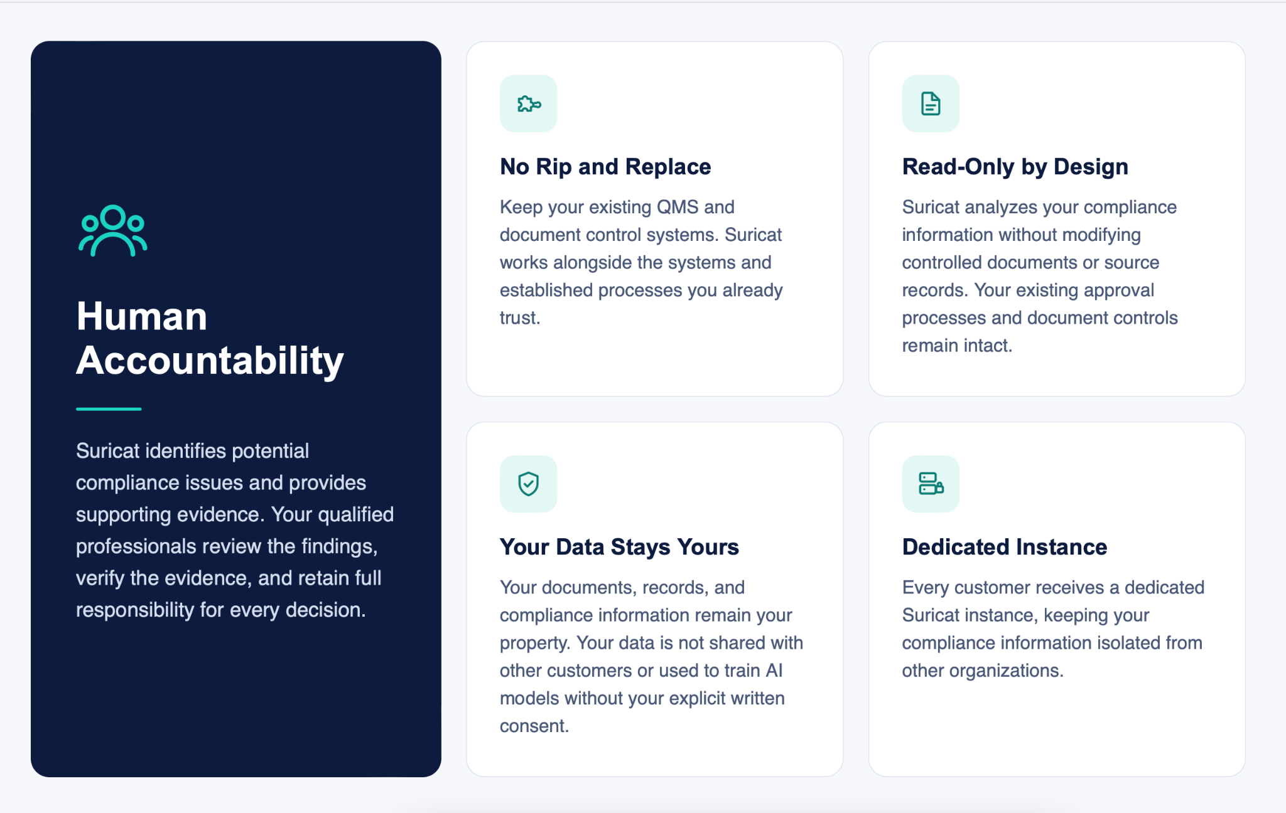
Five Supporting Cards
1. HUMAN ACCOUNTABILITY
Suricat identifies potential compliance issues and provides supporting evidence. Your qualified professionals review the findings, verify the evidence, and retain full responsibility for every decision.
2. NO RIP AND REPLACE
Keep your existing QMS and document control systems. Suricat works alongside the systems and established processes you already trust.
3. READ-ONLY BY DESIGN
Suricat analyzes your compliance information without modifying controlled documents or source records. Your existing approval processes and document controls remain intact.
4. YOUR DATA STAYS YOURS
Your documents, records, and compliance information remain your property. Your data is not shared with other customers or used to train AI models without your explicit written consent.
5. DEDICATED INSTANCE
Every customer receives a dedicated Suricat instance, keeping your compliance information isolated from other organizations.

WHY SURICAT
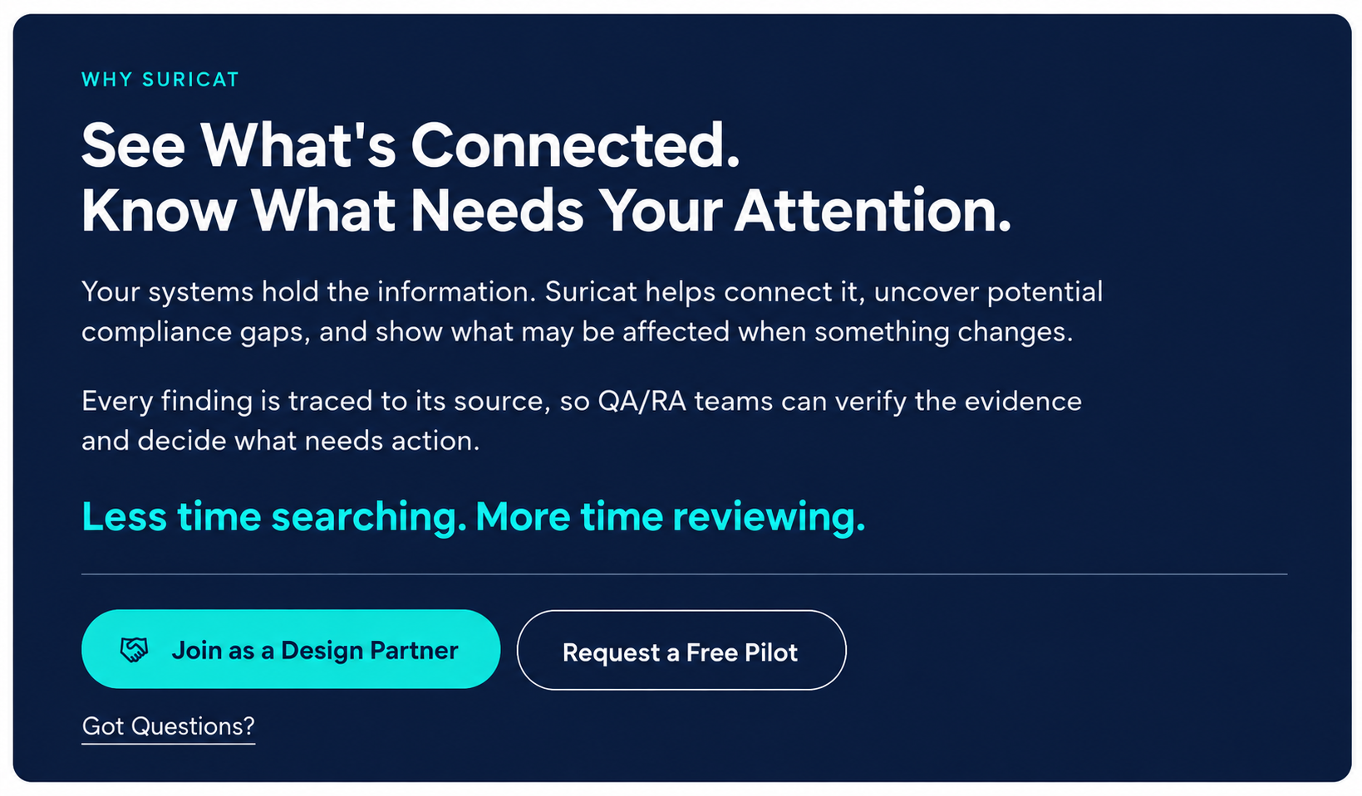
DESIGN PARTNER PROGRAM

Help Define the Future of Compliance Intelligence.
Get early access to Suricat and work directly with our founding team to shape how MedTech QA/RA teams manage compliance.



Footer
